IPL DATA ANALYTICS


QTREE TECHNOLOGIES

Student Registration Number | 2026QT051
Name | Harish E
Course | Python with Data Analytics & ML Integration
Project Guide | Ms. Nithya Ravi
Institute | Qtree Technologies
Course Start Date | 17-12-2026
Course End Date | 02-05-2026
Project Submitted On | 17-08-2026

Authorized Signature Trainer Signature

Contents | Page No.
Abstract
1. Introduction  1.1 IPL Overview  1.2 Importance of Cricket Analytics  1.3 Business Needs | 1
2. Problem Statement and Project Objectives | 2
3. Dataset Description | 2
4. System Specification  4.1 Hardware Requirements  4.2 Software Requirements  4.3 Python Libraries | 3
5. Data Flow Diagram (DFD) | 3
6. Database Design  6.1 Ball_by_Ball_Data  6.2 IPL_Matches_Data  6.3 Players_Data_Updated  6.4 Teams_Data | 6
7. Data Modeling  7.1 Fact Table  7.2 Dimension Tables | 8
8. Dashboard Modules  8.1 Overview Dashboard  8.2 Batting Analysis Dashboard  8.3 Bowling Analysis Dashboard  8.4 Team Analysis Dashboard  8.5 Venue Analysis Dashboard  8.6 AI Analysis & ML Predictions Dashboard | 9
9. DAX Measures  9.1 Season Winner with Trophy – DAX Measure  9.2 Orange Cap Holder – DAX Measure | 13
10. Python Source Code  10.1 IPL Run Momentum Curve – Python Visual  10.2 Wicket Fall by Phase – Python Visual | 16
13. Machine Learning Model | 24
14. Results | 30
15. Future Enhancements | 30
16. Conclusion | 30

Abstract
The Indian Premier League (IPL) generates millions of ball-by-ball records every season, making it challenging to derive meaningful insights through manual analysis. This project aims to transform raw IPL data into actionable insights by leveraging Data Analytics, Business Intelligence, and Machine Learning techniques. The primary objective is to analyze team performance, player performance, venue statistics, batting and bowling trends, and forecast future match outcomes using historical IPL data. The project utilizes comprehensive IPL datasets containing ball-by-ball, match, player, team, and venue information spanning multiple seasons. An end-to-end analytics workflow was implemented, including:
- Data collection and integration from IPL datasets.
- Data cleaning, preprocessing, and feature engineering using Python.
- Data storage and management using MySQL.
- Exploratory Data Analysis (EDA) to identify performance patterns and trends.
- Interactive dashboard development using Power BI and DAX.
- Machine Learning models for predicting future runs, wickets, and match-related insights.
The analytical phase provides detailed insights into team performance, batting consistency, bowling effectiveness, venue behavior, player rankings, scoring patterns across different match phases, and season-wise performance trends. Advanced Power BI dashboards were developed to visualize key performance indicators, including Orange Cap and Purple Cap standings, points tables, venue analysis, batting partnerships, bowling statistics, powerplay performance, middle-over analysis, and death-over efficiency.
Machine Learning techniques were applied to forecast future runs and wickets based on historical player and match statistics, enabling predictive insights that support strategic decision-making. The integration of SQL, Python, Power BI, DAX, and Machine Learning demonstrates how modern data analytics can convert large-scale cricket datasets into interactive visualizations and accurate predictive models. Overall, this project highlights the effective application of data engineering, analytics, business intelligence, and predictive modeling in sports analytics. The resulting solution provides valuable insights for cricket analysts, coaches, franchises, broadcasters, and enthusiasts by facilitating data-driven decision-making and enhancing the understanding of player and team performance in the Indian Premier League.

Keywords: IPL Analytics, Cricket Analytics, Data Analytics, Machine Learning, Predictive Modeling, Python, SQL, MySQL, Power BI, DAX, Sports Analytics, Data Visualization, Run Prediction, Wicket Prediction.

IPL DATA ANALYTICS
1. Introduction

1.1. IPL Overview
The Indian Premier League (IPL) is the world's premier professional Twenty20 (T20) cricket league, organized annually by the Board of Control for Cricket in India (BCCI) since its inception in 2008. The tournament features franchise-based teams representing different Indian cities and brings together some of the finest domestic and international cricketers. Over the years, the IPL has evolved into one of the most popular and commercially successful sporting leagues worldwide, attracting millions of viewers, sponsors, and cricket enthusiasts.
In this project, historical IPL data is transformed into an interactive Power BI dashboard integrated with SQL, Python, DAX, Artificial Intelligence (AI), and Machine Learning (ML). The dashboard provides comprehensive insights into batting, bowling, fielding, team performance, venue analysis, and predictive analytics, helping users make informed decisions through data-driven visualization and forecasting.

1.2. Importance of Cricket Analytics
Cricket analytics has become an essential component of modern cricket, enabling teams, coaches, analysts, broadcasters, and franchise owners to make informed decisions using historical and real-time data.

1.3. Business Needs
- Centralized Data Analysis: Integrate multiple IPL datasets into a single platform for comprehensive analysis.
- Performance Monitoring: Track player, team, bowling, batting, and venue performance through interactive dashboards.
- Data-Driven Decision Making: Provide reliable insights to support team selection, match planning, and tactical decisions.
- Predictive Analytics: Forecast future runs, wickets, and performance trends using AI and Machine Learning models.
- Operational Efficiency: Reduce manual data processing and reporting by automating calculations and visualizations.
- Interactive Reporting: Enable users to explore data dynamically using filters, slicers, drill-throughs, and custom visualizations.
- Strategic Planning: Support franchise management in player evaluation, auction planning, and long-term performance assessment.

2. Problem Statement and Project Objectives
Millions of IPL ball-by-ball records are generated every season, making manual analysis and decision-making challenging. This project aims to transform raw cricket data into meaningful insights by leveraging SQL, Python, Power BI, DAX, and Machine Learning. The objective is to analyze team and player performance, evaluate batting, bowling, and venue statistics, forecast future runs and wickets using predictive models, and develop interactive dashboards that enable data-driven analysis and visualization for cricket enthusiasts, analysts, and decision-makers.

3. Dataset Description
Ball_By_Ball_Data
Ipl_Matches_Data
Players_Updated_Data
Teams_Data
Dataset | Description
Matches | Match information: Match ID, Season, Date, Venue, Winner
Ball_by_Ball | Every delivery:  Batter,Bowler,Runs,Extras,Wickets,Over,Balls etc.,
Players | Player details: Player Name, Image Url
Teams | Team information: Team Name, Team Image Url

4. System Specification

4.1. Hardware Requirements
Processor | 11th Gen Intel(R) Core(TM) i3-1115G4 @ 3.00GHz (3.00 GHz)
RAM | 12 GB
Display | 1366 × 768
Internet | Required for updates and online resources

4.2. Software Requirements
Software | Version
Operating System | Windows 11 (64-bit)
Microsoft Power BI Desktop | Version: 2.152.1279.0 64-bit
MySQL Server | 8.0
MySQL Workbench | 8.0
Python | 3.10
Microsoft Excel | 2013

4.3. Python Libraries
Library | Purpose
pandas | Data manipulation
numpy | Numerical computation
matplotlib | Data visualization
scikit-learn | Machine Learning
mysql-connector-python | MySQL connectivity

5. Data Flow Diagram (DFD)

Level-0 DFD
IPL CSV Files

Data Cleaning (ETL)

MySQL Database

Power BI Data Model

Dashboard

AI Prediction Module

Figure 1: Level 0 Data Flow Diagram
Level-1 DFD Level-1 DFD
CSV Files

Players.csv

Matches.csv

Ball_by_Ball.csv

Teams.csv

Data Cleaning
(Remove Nulls/Duplicates)

Feature Engineering

MySQL Tables

Power BI Import

Data Model

Dashboard

DAX Measures

Figure 2: Level 1 DFD Diagram
Python + ML

6. Database Design

6.1 Ball_by_Ball_Data
The Ball_by_Ball_Data table is the central fact table that stores detailed information for every delivery bowled in an IPL match. Each row represents a single ball, making it the primary source for statistical analysis and dashboard visualizations.
Primary Key - Match_ID

Foreign Keys
- Batter , Bowler, Team Batting & Team bowling
Important Columns
Column | Description
Match_ID | Unique match identifier
Innings | Innings number
Over_Number | Over in which the ball was bowled
Ball_Number | Ball number within the over
Batter | Batter facing the delivery
Bowler | Bowler delivering the ball
Team_Batting | Batting team
Team_Bowling | Bowling team
Batter_Runs | Runs scored by the batter
Extras | Extra runs awarded
Total_Runs | Total runs scored
Is_Wicket | Indicates if a wicket fell
Player_Out | Name of the dismissed player

6.2 IPL_Matches_Data
The IPL_Matches_Data table stores match-level information for every IPL game, including participating teams, venue, winner, and match details.
Primary Key - Match_ID
Important Columns
Column | Description
Match_ID | Unique match identifier
Match_Date | Date of the match
Season | IPL season
Team1 | First team
Team2 | Second team
Venue | Match venue
City | Match city
Winner | Winning team
Player_of_Match | Player of the Match

6.3 Players_Data_Updated
The Players_Data_Updated table contains player profile information used for player-based analysis.
Primary Key - Player_ID
Important Columns
Column | Description
Player_ID | Unique player identifier
Player_Name | Player name
Full_Name | Full player name
Batting_Style | Right/Left-handed batting
Bowling_Style | Bowling style
Playing_Role | Batter, Bowler, All-rounder, Wicketkeeper

6.4 Teams_Data
The Teams_Data table stores information about IPL franchises.

Primary Key - Team_ID

Important Columns
Column | Description
Team_ID | Unique team identifier
Team_Name | Team name
Short_Name | Team abbreviation
Team_Logo | Team logo URL

7. Data Modeling
The IPL Analytics project follows a Star Schema data model, where the Ball-by-Ball Data acts as the central fact table and is connected to multiple dimension tables such as Players, Teams, Matches, Season Summary, and Venue Summary. This model minimizes data redundancy, improves query performance, and enables efficient filtering, aggregation, and interactive reporting in Power BI.

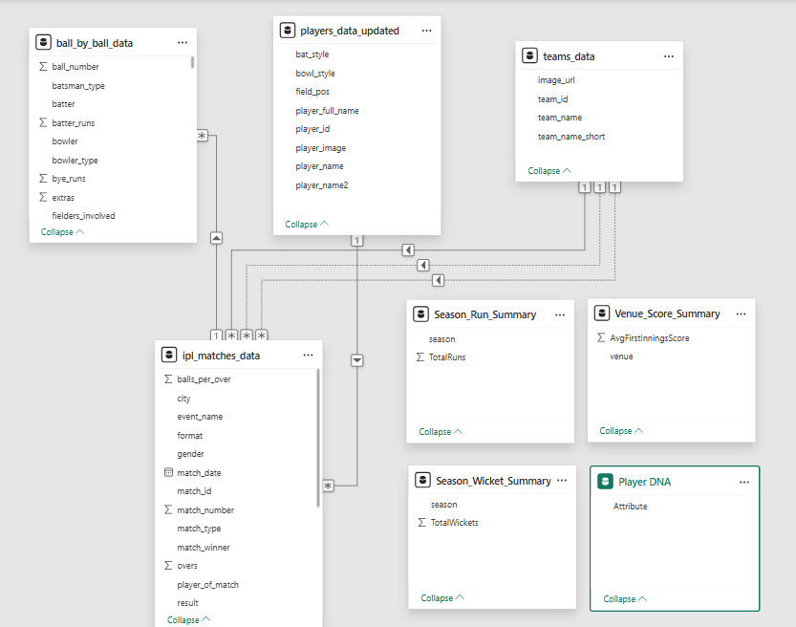
Figure 3: Data Modeling

7.1 Fact Table

Ball_by_Ball_Data (Fact Table)
The Ball_by_Ball_Data table is the central fact table of the IPL Analytics dashboard. It stores detailed transactional information for every ball delivered in every IPL match. Since each record represents a single delivery, it serves as the primary source for all statistical calculations and dashboard visualizations.

7.2 Dimension Tables

i)IPL_Matches_Data
The IPL_Matches_Data table contains match-level information for every IPL game.

ii. Players_Data_Updated
The Players_Data_Updated table stores descriptive information about IPL players.

iii. Teams_Data
The Teams_Data table contains information about IPL franchises.

iv. Season_Run_Summary
This table stores season-level aggregated run statistics.

v. Season_Wicket_Summary
This table contains aggregated wicket statistics for each IPL season.

vi. Venue_Score_Summary
This table contains average first-innings scores for every venue.

8. Dashboard Modules
8.1 Overview
The IPL Data Analytics & AI-Driven Performance Dashboard is divided into multiple modules to provide a comprehensive view of IPL performance from different analytical perspectives. Each module focuses on a specific area such as overall tournament performance, batting, bowling, team performance, venue analysis, and AI-based predictions.
Executive Dashboard: Provides an overall summary of IPL performance through key KPIs and high-level insights.
KPIs
- Total Runs
- Total Wickets
- Matches
- Orange Cap

- Purple Cap
- Season Winner
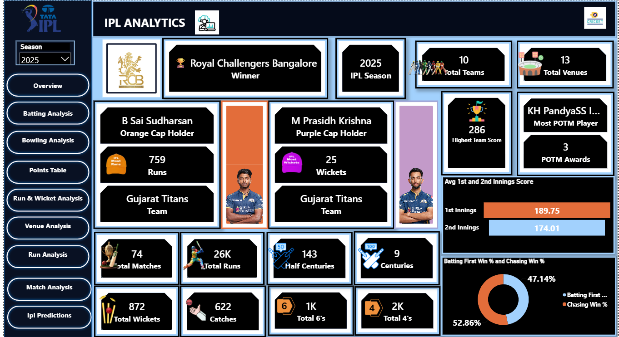
Figure 4: Overview Dashboard

8.2 Batting Analysis Dashboard
Analyzes player batting performance using runs, averages, strike rates, boundaries, and other metrics.
- Highest Score , Strike Rate, Average, Boundary% & Six%
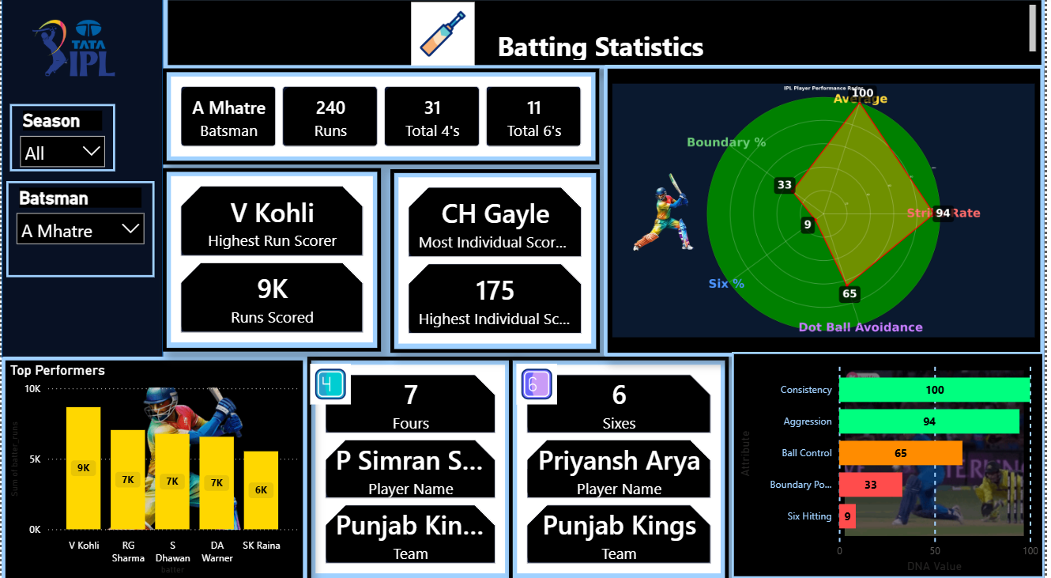
Figure 5: Batting Analysis Dashboard
8.3 Bowling Analysis Dashboard
Evaluates wickets, economy rates, bowling performance, and fielding contributions.
- Economy ,Wickets, Five-Wicket Hauls
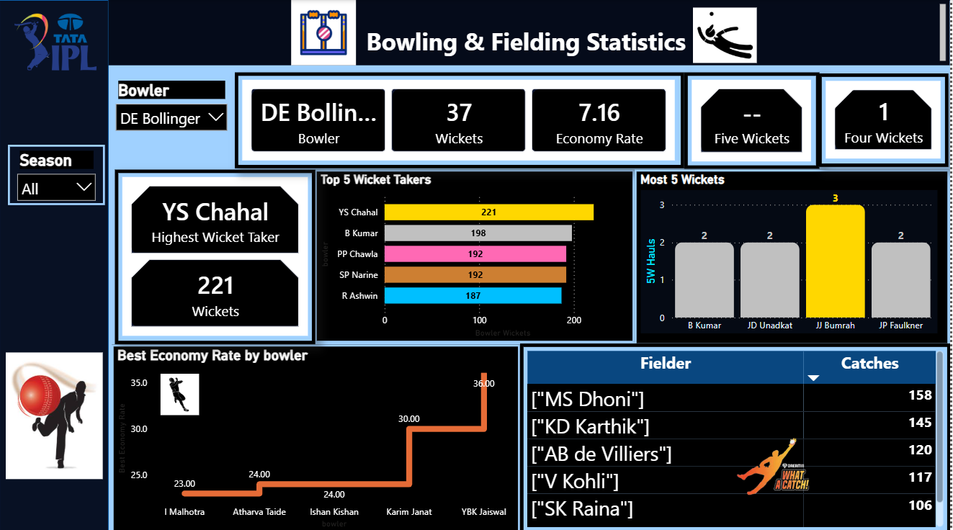
Figure 6: Bowling & Fielding Analysis Dashboard

8.4 Team Analysis Dashboard
Compares team results, wins, losses, points, and overall performance trends.
- Total Matches Played ,Matches, Won, lost, Tied and No Result
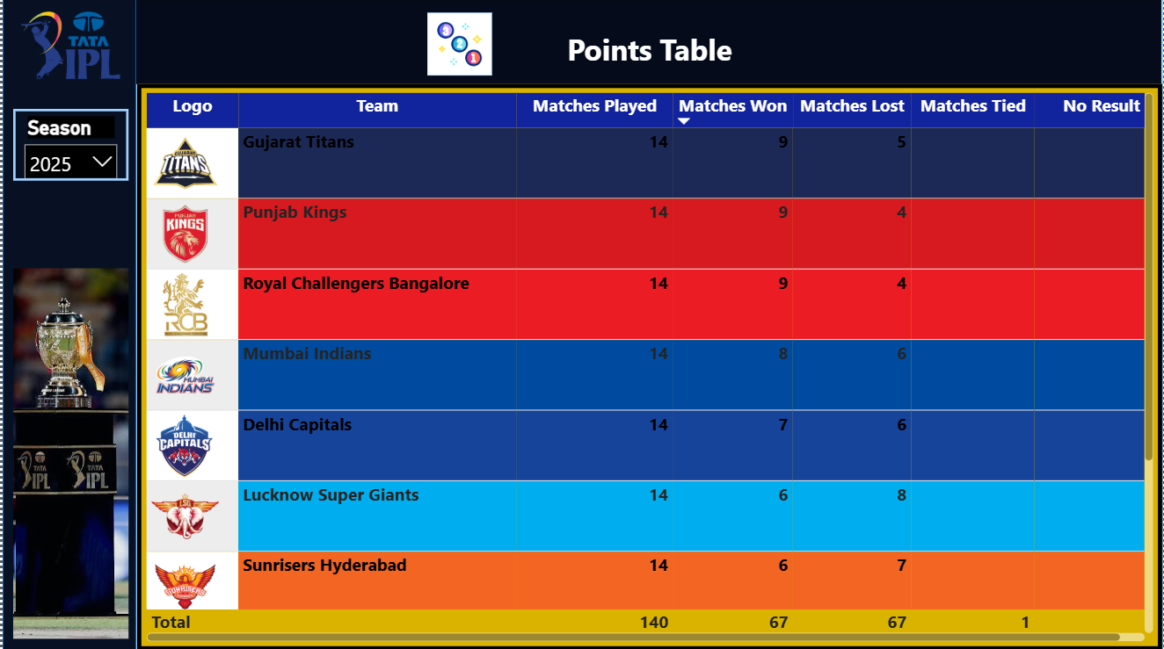
Figure 7: Points Table

8.5 Venue Analysis Dashboard

Analyzes venue-wise scoring patterns, average first-innings scores, and ground characteristics.
- Average First Innings Score ,Venue Type ,Win Analysis
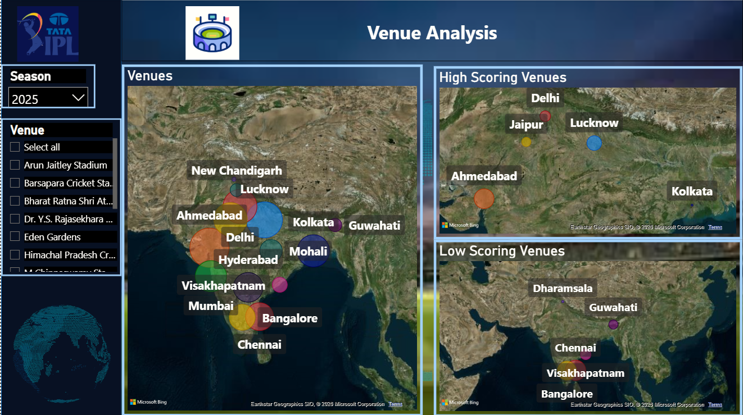
Figure 8: Venue Analysis Dashboard

8.6 AI Analysis & ML Predictions Dashboard

Uses Python and Machine Learning to forecast runs, wickets, and performance trends.
- Future Runs Prediction ,Future Wickets Prediction ,Forecast ,Trend Analysis
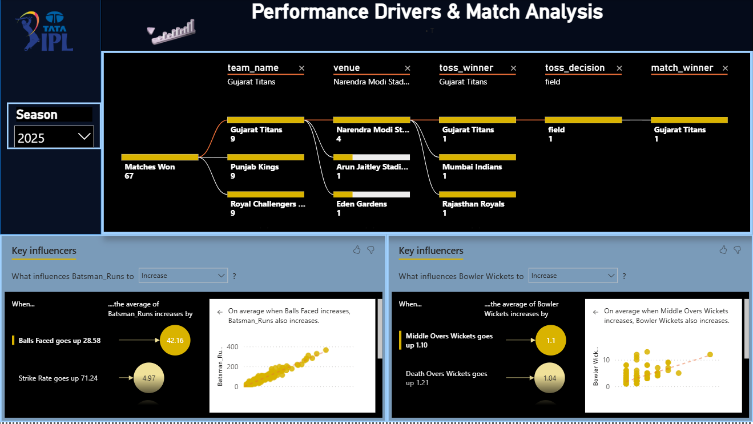
Figure 9: Performance Drivers & Match Analysis Dashboard

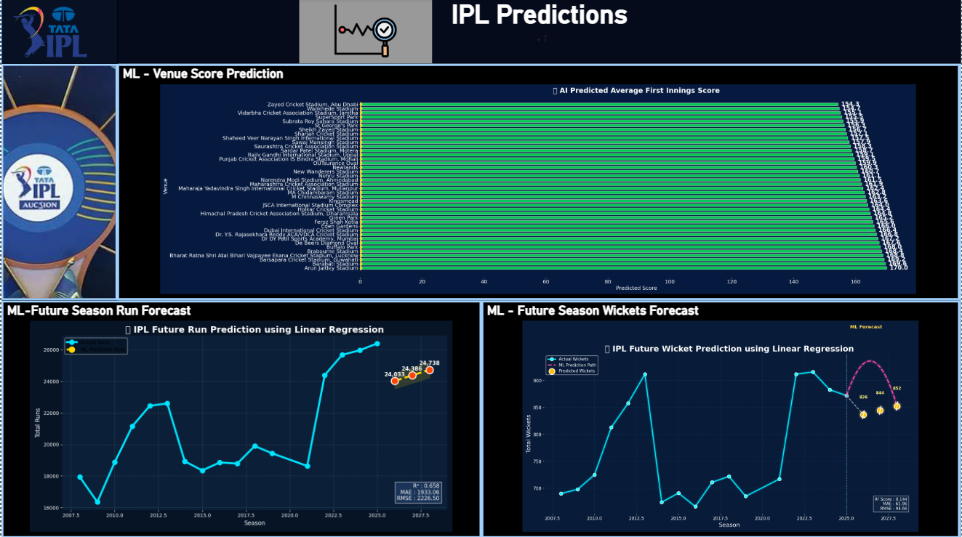
Figure 10: IPL Predictions Dashboard
9. DAX Measures

9.1. Season Winner with Trophy – DAX Measure

Purpose
The Season Winner with Trophy measure is used to dynamically display the winner of the selected IPL season in the Power BI dashboard. It identifies the latest match played in the selected season and retrieves the team that won that match. A trophy emoji is then added to make the result visually suitable for a dashboard card.

DAX Code
Season Winner with Trophy =
VAR SelectedSeason =
SELECTEDVALUE(ipl_matches_data[season])
SELECTEDVALUE()
- retrieves the season currently selected by the user through the Power BI slicer.
VAR FinalMatchDate =
CALCULATE(
MAX(ipl_matches_data[match_date]),
ipl_matches_data[season] = SelectedSeason
)
- MAX() finds the latest match date for the selected season.
- Therefore, the measure assumes that the latest match date represents the final match of that season.
VAR FinalMatchWinner =
CALCULATE(
MAX(ipl_matches_data[match_winner]),
ipl_matches_data[season] = SelectedSeason,
ipl_matches_data[match_date] = FinalMatchDate
)
- CALCULATE() - filters the data based on:
- Selected season
- Final match date
- It then retrieves the match_winner corresponding to that final match.
RETURN
" " & FinalMatchWinner
- The RETURN statement combines the trophy emoji with the winning team's name.

9.2. Orange Cap Holder – DAX Measure

Purpose
The Orange Cap Holder measure identifies the top run-scorer for the selected IPL season. It filters the ball-by-ball data according to the season selected by the user, calculates the total runs scored by each batter, finds the maximum run total, and identifies the player or players who achieved that score.

DAX Code
Orange Cap Holder =
VAR SelectedSeason =
SELECTEDVALUE(ipl_matches_data[season])
- SELECTEDVALUE() retrieves the season selected through the Power BI slicer.
VAR SeasonDataOnly =
FILTER(
ball_by_ball_data,
RELATED(ipl_matches_data[season]) = SelectedSeason
)
- FILTER() restricts the ball-by-ball data to the selected season.
- RELATED() retrieves the season value from the related ipl_matches_data table using the established relationship between the tables.
- Therefore, only deliveries belonging to the selected season are considered.
VAR RunSummary =
SUMMARIZE(
SeasonDataOnly,
ball_by_ball_data[batter],
"Total Runs", SUM(ball_by_ball_data[batter_runs])
)
- SUMMARIZE() creates a temporary summary table containing:
- Batter name
- Total runs scored by that batter
VAR MaxRuns =
MAXX(RunSummary, [Total Runs])
- MAXX() evaluates the Total Runs value for every player in RunSummary and returns the highest value.
VAR TopScorer =
FILTER(
RunSummary,
[Total Runs] = MaxRuns
)
- FILTER() returns the player or players whose total runs are equal to the maximum run value.
RETURN
MAXX(TopScorer, ball_by_ball_data[batter])
- This returns the name of the top scorer identified by the calculation.

12. Python Source Code

12.1. IPL Run Momentum Curve – Python Visual

Purpose
The IPL Run Momentum Curve is a Python-based Power BI visual designed to show how runs are distributed across different overs of an IPL innings. It helps identify scoring patterns across the three major phases of an innings:
- Powerplay: Overs 0–5
- Middle Overs: Overs 6–14
- Death Overs: Overs 15–19
The visual uses a line chart with an area fill and phase-based background highlighting to make the scoring momentum easier to interpret.

Python Libraries Used
import pandas as pd
import matplotlib.pyplot as plt
Library | Purpose
pandas | Data manipulation, grouping, and aggregation
matplotlib.pyplot | Creating and formatting the visualization

Load the Power BI Dataset
df = dataset.copy()
- The dataset object contains the data passed from the Power BI Python visual. copy() creates a separate DataFrame so that the original Power BI dataset is not modified.

Calculate Runs per Over
over_runs = (
df.groupby('over_number')['total_runs']
.sum()
.reset_index()
.sort_values('over_number')
)
- The data is grouped by over_number and the total_runs for each over are summed.
- This provides the foundation for the run momentum curve.

Configure the Chart Theme
fig, ax = plt.subplots(figsize=(38,10))

fig.patch.set_facecolor('#0B132B')
ax.set_facecolor('#0B132B')
- A dark background is applied to create a stadium/neon-style dashboard appearance consistent with the IPL analytics project.

Highlight the Three Innings Phases
ax.axvspan(0,5,...)
ax.axvspan(6,14,...)
ax.axvspan(15,19,...)
- axvspan() creates background regions representing the three phases:
- This allows users to visually compare scoring behavior between phases.

Create the Glow Effect
for lw, alpha in [(12,0.08),(8,0.15),(5,0.25)]:
ax.plot(...)
- Multiple lines with different widths and transparency levels are layered together to create a glowing line effect.
- This enhances the visual appearance without changing the underlying data.

Draw the Main Momentum Curve
ax.plot(
over_runs['over_number'],
over_runs['total_runs'],
color='white',
linewidth=5
)
- The main line represents:
Over Number → Runs Scored
- A higher point indicates greater scoring in that over.

Add Area Fill
ax.fill_between(
over_runs['over_number'],
over_runs['total_runs'],
color='cyan',
alpha=0.15
)
- The area below the line is shaded to improve visual emphasis and make the scoring trend easier to observe.

Display Runs on Each Point
for x, y in zip(over_runs['over_number'], over_runs['total_runs']):
ax.text(...)
- The exact run value is displayed above each point on the curve.
- This allows the user to identify the number of runs scored in each over without estimating from the axis.

Calculate Phase-Wise Runs
powerplay = over_runs[
over_runs['over_number'] <= 5
]['total_runs'].sum()

middle = over_runs[
(over_runs['over_number'] >= 6) &
(over_runs['over_number'] <= 14)
]['total_runs'].sum()
death = over_runs[
over_runs['over_number'] >= 15
]['total_runs'].sum()
- The code calculates the total runs scored during each phase.
- These values are then displayed directly on the chart.

Add Phase Labels
- The visual displays: Powerplay, Middle Over & Death Over Runs
This provides a quick comparison of scoring contribution across the three phases.

Chart Titles and Labels
ax.set_title('IPL RUN MOMENTUM CURVE')
ax.set_xlabel('Over')
ax.set_ylabel('Runs')
- The chart is labeled clearly so that the viewer can understand the variables being represented.

Grid and Formatting
ax.tick_params(colors='white')

for spine in ax.spines.values():
spine.set_color('white')

ax.grid(color='white', alpha=0.10)
- These formatting commands improve readability while maintaining the dark dashboard theme.
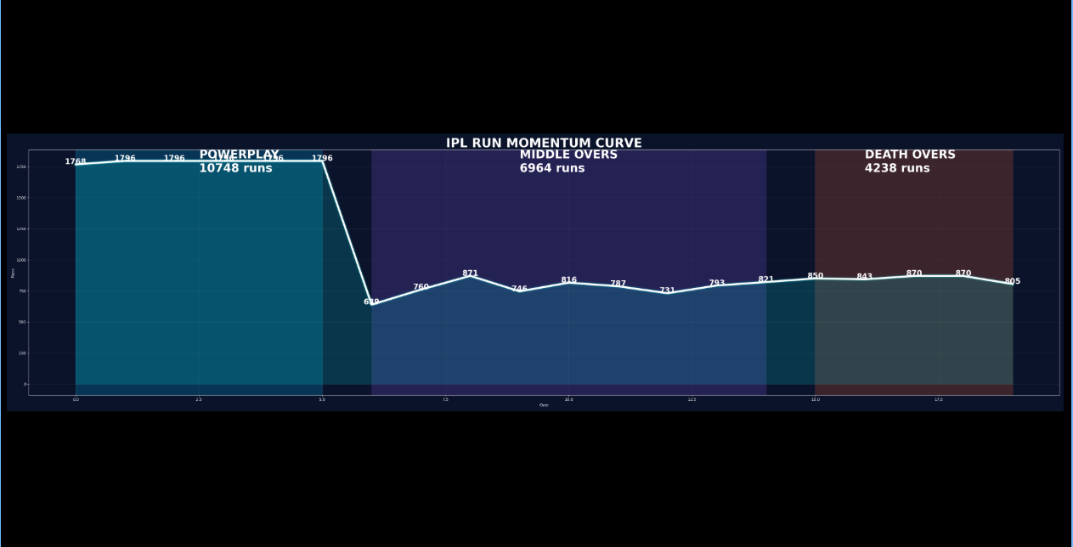
Figure 11: Run Momentum Analysis

12.2. Wicket Fall by Phase – Python Visual

Purpose
The Wicket Fall by Phase visual is a Python-based Power BI visualization that shows the distribution of wickets across the three major phases of an IPL innings:
- Powerplay , Middle & Death Overs
The visual represents the cricket pitch graphically and uses scatter points to show the number of wickets in each phase. It provides a quick visual comparison of when wickets are most frequently lost during an innings.

Python Libraries Used
import pandas as pd
import matplotlib.pyplot as plt
import matplotlib.patches as patches
import numpy as np

Load Power BI Dataset
df = dataset

Aggregate Wickets by Phase
powerplay_wkts = df['Powerplay Wickets'].sum()
middle_wkts = df['Middle Overs Wickets'].sum()
death_wkts = df['Death Overs Wickets'].sum()
The code calculates the total wickets for each phase by summing the corresponding columns.
The calculated values are then used to generate the visual representation.

Create the Visualization Canvas
fig, ax = plt.subplots(figsize=(42, 10))
- A wide figure is created to provide enough space for the pitch, wicket markers, and phase labels.
- A dark background is applied:
fig.patch.set_facecolor('#0f172a')
ax.set_facecolor('#0f172a')
- This provides a dashboard-style appearance consistent with the project's dark/neon visual theme.

Create the Cricket Pitch
pitch = patches.Rectangle(
(0.1, 0.35), 0.8, 0.3,
linewidth=0,
facecolor='#d1a15a',
alpha=0.95
)
ax.add_patch(pitch)
- Rectangle() from matplotlib.patches is used to create a simplified cricket pitch.
- The pitch acts as the central visual area where wicket markers are displayed.

Add Creases and Stumps

Creases
ax.vlines(
[0.2, 0.5, 0.8],
ymin=0.3,
ymax=0.7,
colors='white',
linewidth=2
)
- Vertical lines are used to represent the pitch markings and crease areas.

Stumps
ax.hlines([0.45, 0.5, 0.55], 0.82, 0.88, ...)
ax.hlines([0.45, 0.5, 0.55], 0.12, 0.18, ...)
- Horizontal lines are used to create simplified representations of the stumps at both ends of the pitch.

Divide the Pitch into Three Phases
ax.axvspan(0.1, 0.3, ...) # Powerplay
ax.axvspan(0.3, 0.7, ...) # Middle
ax.axvspan(0.7, 0.9, ...) # Death
- The pitch is visually divided into three zones:

Create Wicket Markers
- A custom function is defined:
def plot_wickets(count, x_start, x_end, color):
- The function generates a number of scatter points based on the number of wickets in each phase.
xs = np.random.uniform(x_start, x_end, count)
ys = np.random.uniform(0.38, 0.62, count)
- Random positions are generated within the appropriate phase zone so that multiple wickets can be displayed without overlapping completely.
- The wickets are then represented using scatter points:
ax.scatter(
xs, ys,
s=300,
color=color,
edgecolors='white',
linewidth=1.5,
alpha=0.9
)
- Each point represents one wicket.

Plot Wickets for Each Phase
plot_wickets(powerplay_wkts, 0.1, 0.3, ...)
plot_wickets(middle_wkts, 0.3, 0.7, ...)
plot_wickets(death_wkts, 0.7, 0.9, ...)
- The function is called separately for each phase.
- Therefore, the number of markers displayed in each zone corresponds to the calculated number of wickets.

Display Phase-Wise Values
- The visual displays the actual wicket counts above the pitch:
ax.text(0.15, 0.78, f"Powerplay: {powerplay_wkts}", ...)
ax.text(0.45, 0.78, f"Middle: {middle_wkts}", ...)
ax.text(0.75, 0.78, f"Death: {death_wkts}", ...)
This makes the visual useful for both:
- Visual comparison
- Exact numerical interpretation

Add Pitch-End Labels
ax.text(0.05, 0.5, "BOWLER END", ...)
ax.text(0.95, 0.5, "BATSMAN END", ...)
- These labels make the pitch representation more recognizable and improve the cricket-specific design of the visual.

Final Formatting
ax.set_xlim(0, 1)
ax.set_ylim(0, 1)
ax.axis('off')
- The axis is hidden because the visual is intended to function as a dashboard infographic rather than a conventional statistical chart.
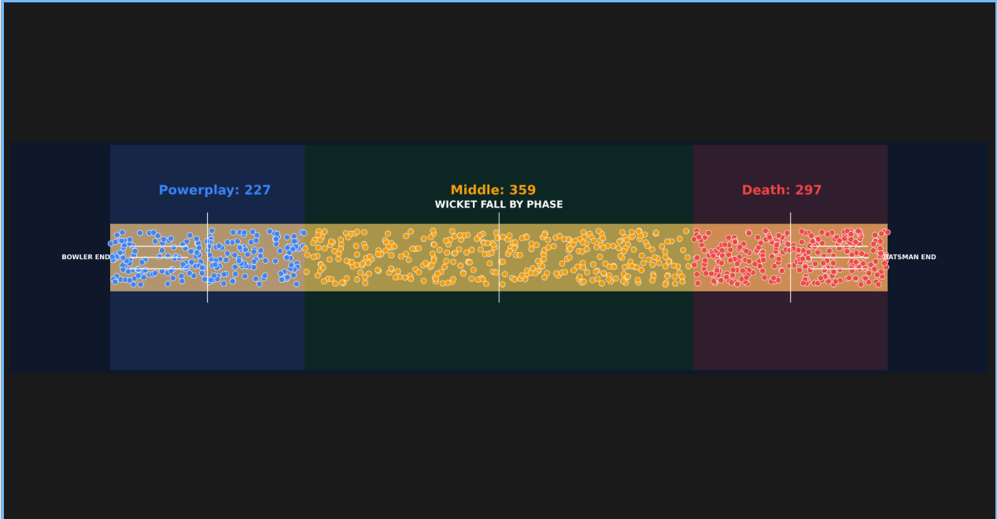
Figure 12: Wicket Analysis

13. Machine Learning Model

IPL Future Run Prediction using Linear Regression

Visual Type: Python-based Machine Learning Predictive Line Chart
More specifically, it is a Time-Series Trend & Forecast Visualization using Linear Regression. It combines:
- Line chart for historical runs
- Dashed forecast line for predicted runs
- Prediction markers & Prediction range/band
- ML evaluation metrics

Purpose: This Python visual uses Linear Regression to analyze the historical total runs scored in each IPL season and predict the total runs for the next three seasons. It compares actual historical performance with ML-generated future predictions.
Libraries Used

import pandas as pd

import numpy as np

import matplotlib.pyplot as plt

from sklearn.linear_model import LinearRegression

from sklearn.model_selection import train_test_split

from sklearn.metrics import r2_score, mean_absolute_error, mean_squared_error
Library / Function | Purpose
Pandas | Data preparation and aggregation
NumPy | Numerical calculations
Matplotlib | Visualization
LinearRegression | Machine Learning prediction
train_test_split | Splits data into training and testing sets
r2_score | Measures model fit
mean_absolute_error | Measures average prediction error
mean_squared_error | Used to calculate RMSE

Load and Prepare Dataset

df = dataset.copy()
- The dataset contains the data passed from the Power BI Python visual.
df['season'] = pd.to_numeric(df['season'], errors='coerce') df['TotalRuns'] = pd.to_numeric(df['TotalRuns'], errors='coerce')
- The season and TotalRuns columns are converted to numeric values:
df = df.dropna(subset=['season', 'TotalRuns'])
- Invalid or missing values are converted to NaN and then removed:
Aggregate Total Runs by Season
df = ( df.groupby('season', as_index=False) .agg({'TotalRuns':'sum'}) )
The data is grouped by IPL season and the total runs are summed.
Define Features and Target
X = df[['season']]
y = df['TotalRuns']
- The ML model uses:
- Feature (X): Season
- Target (y): Total Runs
- Therefore, the model attempts to learn the relationship:
Season → Total IPL Runs
Minimum Data Validation
if len(df) < 3:
- The code checks whether at least three seasons are available.
- If fewer than three seasons exist, the model does not run and displays:
- Need at least 3 seasons for ML Prediction
This prevents the model from being trained on an extremely small dataset.

Train-Test Split
X_train, X_test, y_train, y_test = train_test_split(
X,
y,
test_size=0.20,
random_state=42
)
- The dataset is divided into:
- 80% Training Data
- 20% Testing Data
- The training data is used to build the model, while the testing data is used to evaluate its performance.
random_state=42 ensures reproducibility.

Linear Regression Model
model = LinearRegression()
model.fit(X_train, y_train)
- A Linear Regression model is created and trained using the historical season and total-run data.
- The underlying model can be represented as:
Total Runs = Intercept + (Coefficient × Season)
The model learns the coefficient and intercept from the training data.

Model Prediction
y_pred = model.predict(X_test)
- The trained model predicts total runs for the testing seasons.
- These predictions are then compared with the actual values to evaluate the model.

Model Evaluation
- Three evaluation metrics are calculated.

R² Score
r2 = r2_score(y_test, y_pred)
- R² indicates how well the model explains the variation in total runs.
- A value closer to 1 generally indicates a better fit.

Mean Absolute Error
mae = mean_absolute_error(y_test, y_pred)
- MAE represents the average absolute difference between actual and predicted run values.
- Lower MAE indicates smaller prediction errors.

Root Mean Squared Error
rmse = np.sqrt(mean_squared_error(y_test, y_pred))
- RMSE measures prediction error while giving greater weight to larger errors.
- Lower RMSE indicates better prediction performance.

Future Season Generation
future = pd.DataFrame({
'season': [
X['season'].max()+1,
X['season'].max()+2,
X['season'].max()+3
]
})
- The code generates the next three seasons after the latest season available in the dataset.

Future Run Prediction
prediction = model.predict(future)
- The trained Linear Regression model predicts the expected total IPL runs for each of the three future seasons.

Actual vs Predicted Visualization
The chart contains two main lines.

Actual Runs
ax.plot(
X['season'],
y,
...
label="Actual Runs"
)
- This line represents the historical total runs for each IPL season.

ML Predicted Runs
ax.plot(
future['season'],
prediction
linestyle='--',
label="ML Predicted Runs"
)
- The dashed line represents the predicted total runs for future seasons.
- This makes it easy to distinguish historical performance from future predictions.

Prediction Area
ax.fill_between(
future['season'],
prediction-500,
prediction+500,
...
)
- A visual prediction range of ±500 runs is displayed around each predicted value.
- Important documentation note: this is a visual band created by the code, not a statistically calculated confidence interval.

Prediction Values
ax.scatter(...)
- Each future prediction is highlighted using a marker.
- The predicted run value is displayed above the marker:
ax.text(
x,
y_val+300,
f"{int(y_val):,}",
...
)
- This makes the exact predicted value visible directly on the chart.

ML Metrics on Dashboard
The following values are displayed inside the visual:
R² : ...
MAE : ...
RMSE : ...
- This allows the user to see the model's performance directly within the Power BI dashboard instead of viewing the metrics separately.

Model Details
The code also prints:
print("Intercept :", model.intercept_)
print("Coefficient :", model.coef_[0])
- These values describe the Linear Regression equation.
- The model can therefore be expressed as:
Predicted Total Runs = Intercept + (Coefficient × Season)
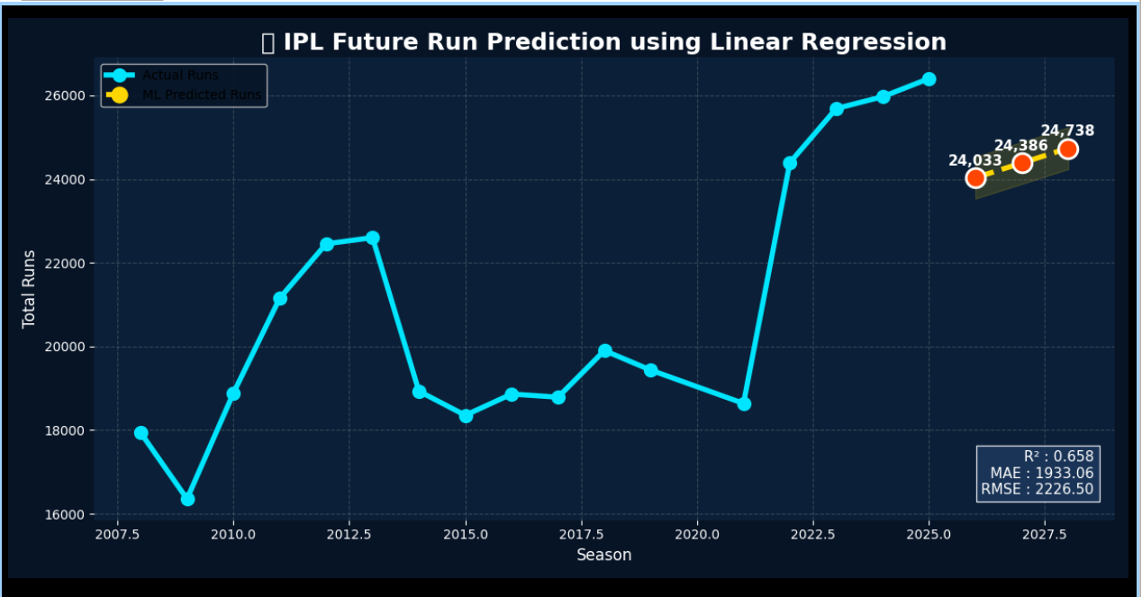

Figure 13: IPL Future Run Prediction

14. Results
- Interactive dashboard developed.
- SQL integrated with Power BI.
- Python visuals embedded.
- AI forecasting implemented.
- Decision-making improved through visual analytics.

15. Future Enhancements
- Live IPL API
- Match Winner Prediction
- Player Auction Prediction
- Fantasy Team Recommendation
- AI Chatbot
- K-Means Player Clustering
- Deep Learning Forecasting

16. Conclusion
The IPL Data Analytics & AI-Driven Performance Dashboard successfully integrates SQL, Python, Power BI, DAX, and Machine Learning into a unified analytics platform. It enables interactive exploration of team, player, venue, and match performance while providing predictive insights through AI-based forecasting. The solution demonstrates how business intelligence and machine learning can transform large-scale sports data into actionable decision support

